Project Design Phase-II

Data Flow Diagram & User Stories

|  |  |
| --- | --- |
| Date | 26. 10. 2022 |
| Team ID | B9-3A5E |
| Project Name | Project - Digital Naturalist - AI Enabled tool for  Biodiversity Researchers |
| Maximum Marks | 4 Marks |

# Data Flow Diagrams:

A Data Flow Diagram (DFD) is a traditional visual representation of the information flows within a system. A neat and clear DFD can depict the right amount of the system requirement graphically. It shows how data enters and leaves the system, what changes the information, and where data is stored.

# Simplified DFD:

1. User uploads the image of flora / fauna.
2. The Python application sends it to IBM Cloud.
3. The CNN model accepts the image as the input to test the model.
4. The CNN model predicts the name of the species.
5. The output is returned to the application.
6. The application displays the received information.

# DFD Standard :

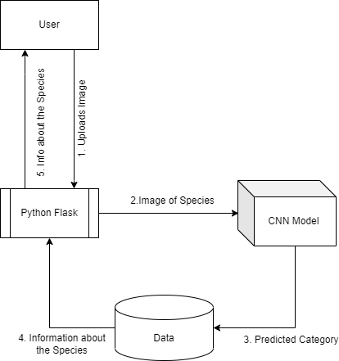

**User Stories**

Use the below template to list all the user stories for the product.

|  |  |  |  |  |  |  |
| --- | --- | --- | --- | --- | --- | --- |
| **User Type** | **Functional Requirement**  **(Epic)** | **User Story Number** | **User Story / Task** | **Acceptance criteria** | **Priority** | **Release** |
| Customer (Web user) | Photo uploading | USN-1 | The user can upload the picture of flora and fauna and get the detailed information of the species | I can upload pictures using dashboard | High | Sprint-1 |
| Customer (Web  user) | Predicting  Species | USN-2 | The detailed information of the species is  displayed in the webpage | CNN model predicts the  species | High | Sprint-2 |